# GoToMeeting Host Instructions:

Here are the sign on credentials:

<https://global.gotomeeting.com>

**User name:** [**Dist8-DR@al-anon-8ny.org**](mailto:Dist8-DR@al-anon-8ny.org)

**Password:  Keepitsimple2**

* **Anyone with the credentials can sign on and host the meeting**
* **You will need to change the host name from *District Representative* to *your name*.**

## How to Change Host Name

To see the list of participants click on the Participants icon



And the list of attendees will show to the right of the video screen.

* ***Click*** on the ***down arrow*** on the ***District Representative*** Me (Org)



* ***Scrol****l* to ***Edit Your Name and Email***

The following screen will appear:

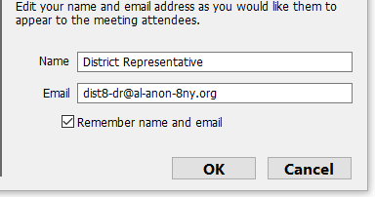

* *Change*  District Representative to you name
* DO NOT CHANGE EMAIL ADDRESSS

**Please be sure and sign out after every meeting! This prevents issues for other groups when they sign in.**

on the upper left corner and Choose *Sign Ou*t

**REMEMBER TO CHANGE THE NAME BACK TO MEETING HOST AND TO SIGN OUT!!!**

**THANK YOU!**